February 15, 2024

Aziz Prastyo Wibowo

PT Mitra Integrasi Informatika

[Company address]

Oracle EM Cloud Control

Installation ver. 13.5 (Confidential)

Oracle EM Cloud Control 13.5 Installation on OEL8

Assume that the DB for repository already installed on same host. Oracle DB 19.22 EE with EMCDB & EMPDB and using default port (1521).

|  |
| --- |
| [oracle@mysqlcirebon Downloads]$ ls -lh em*  -rw-r--r-- 1 oracle oinstall 1.8G Feb 15 08:50 em13500_linux64-2.zip  -rw-r--r-- 1 oracle oinstall 2.0G Feb 15 08:51 em13500_linux64-3.zip  -rw-r--r-- 1 oracle oinstall 1.4G Feb 15 08:51 em13500_linux64-4.zip  -rw-r--r-- 1 oracle oinstall 1.4G Feb 15 08:51 em13500_linux64-5.zip  -rw-r--r-- 1 oracle oinstall 1.5G Feb 15 08:49 em13500_linux64.bin  [oracle@mysqlcirebon Downloads]$ chmod +x em*bin  [oracle@mysqlcirebon Downloads]$ ls -lh em*  -rw-r--r-- 1 oracle oinstall 1.8G Feb 15 08:50 em13500_linux64-2.zip  -rw-r--r-- 1 oracle oinstall 2.0G Feb 15 08:51 em13500_linux64-3.zip  -rw-r--r-- 1 oracle oinstall 1.4G Feb 15 08:51 em13500_linux64-4.zip  -rw-r--r-- 1 oracle oinstall 1.4G Feb 15 08:51 em13500_linux64-5.zip  -rwxr-xr-x 1 oracle oinstall 1.5G Feb 15 08:49 em13500_linux64.bin  [oracle@mysqlcirebon Downloads]$ ./em13500_linux64.bin  Launcher log file is /tmp/OraInstall2024-02-15_09-07-08AM/launcher2024-02-15_09-07-08AM.log.  Extracting the installer . . . . . . . . . . . . . . . . . . . . . . . . . . . . . . . . . . . . . . . . . . . . . . . . . . . . . . . . . . . . . . . . . . . . . . . . . . . . . . . . . . . . . . . . . . . . . . . . . . . . . . . . . . . . . . . . . . . . . . . . . . . . . . . . . . . . . . . . . . . . . . . . . . . . . . . . . . . . . . . . . . . . . . . . . . . . . . . . . . . . . . . . . . . . . . . . . . . . . . . . . . . . . . . . . . . . . . . . . . . . . . . . . . . . . . . . . . . . . . . . . . . . . . . . . . . . . . . . . . . . . . . . . . Done  Checking monitor: must be configured to display at least 256 colors. Actual 16777216 Passed  Checking swap space: must be greater than 512 MB. Actual 4095 MB Passed  Checking if this platform requires a 64-bit JVM. Actual 64 Passed (64-bit not required)  Preparing to launch the Oracle Universal Installer from /tmp/OraInstall2024-02-15_09-07-08AM  ScratchPathValue :/tmp/OraInstall2024-02-15_09-07-08AM  Feb 15, 2024 9:12:12 AM org.apache.sshd.common.io.DefaultIoServiceFactoryFactory getIoServiceProvider  INFO: No detected/configured IoServiceFactoryFactory using Nio2ServiceFactoryFactory  ..................................................................................................  Installation in progress (Thursday, February 15, 2024 10:41:04 AM GMT) |

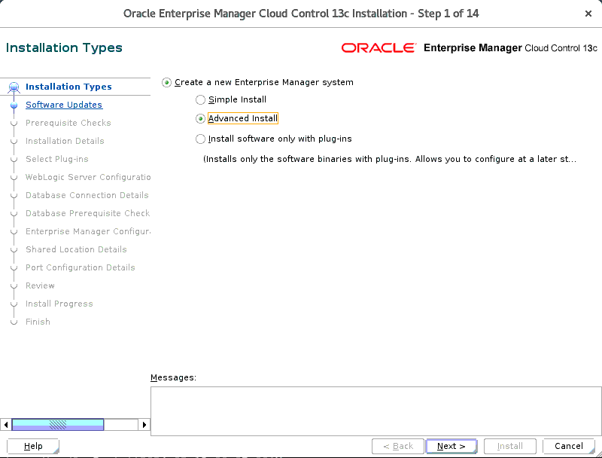

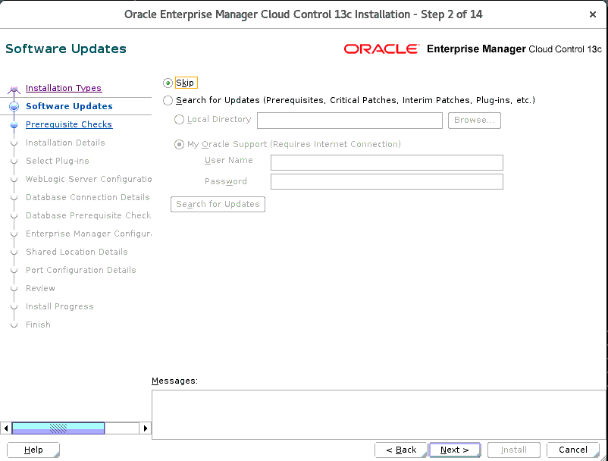

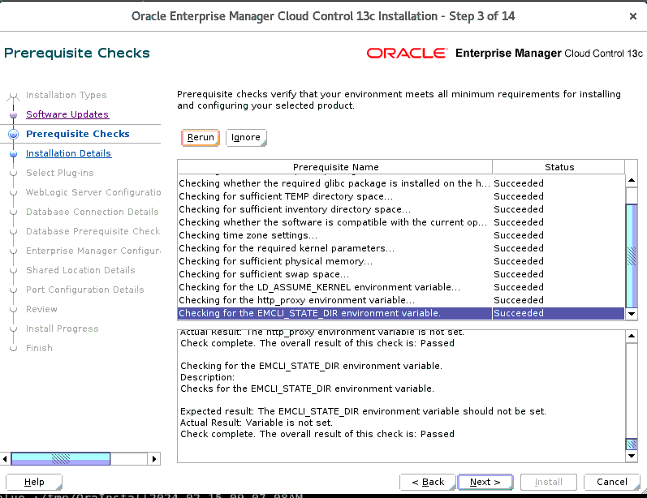

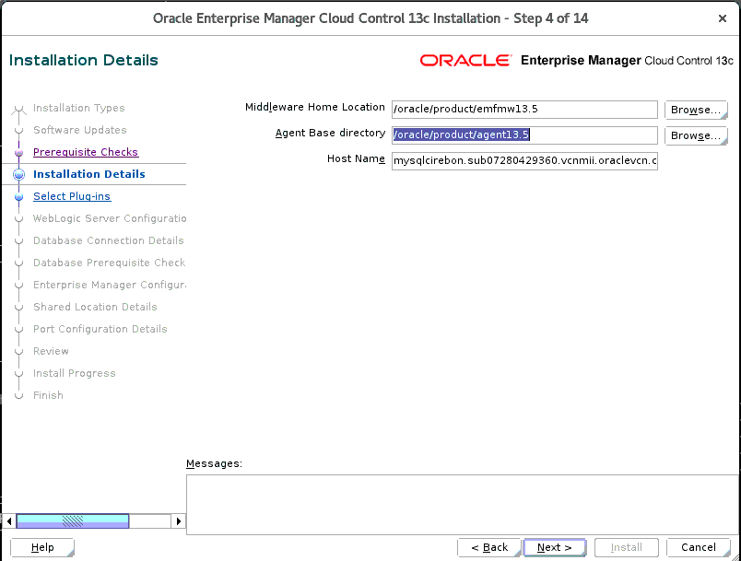

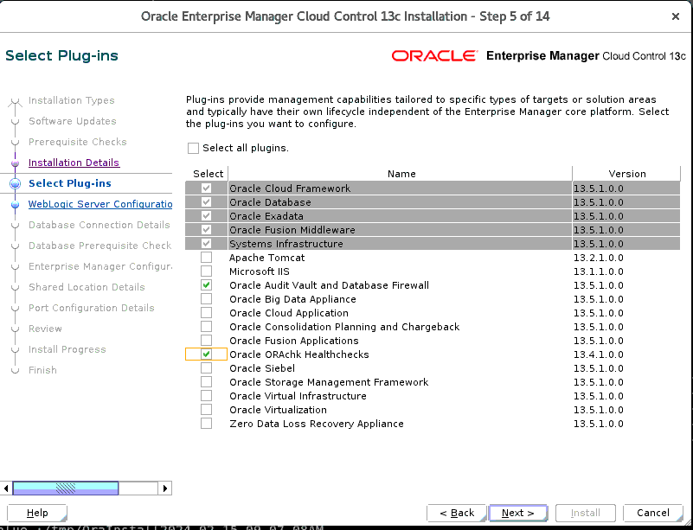

Paswd: oracle123

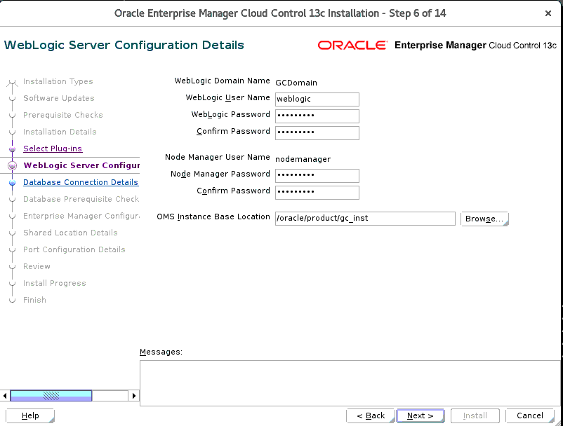

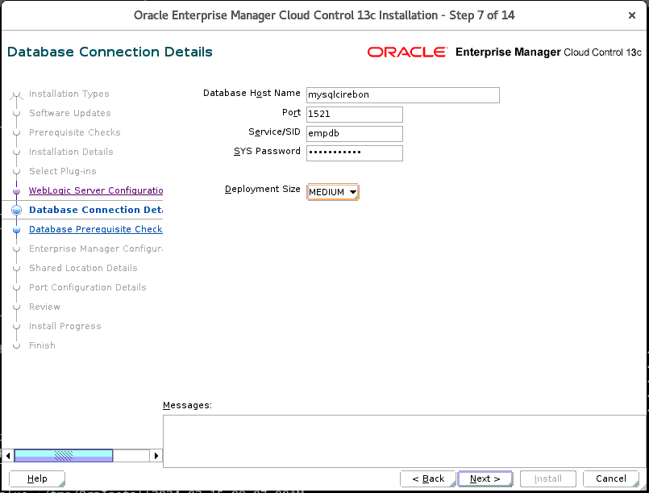

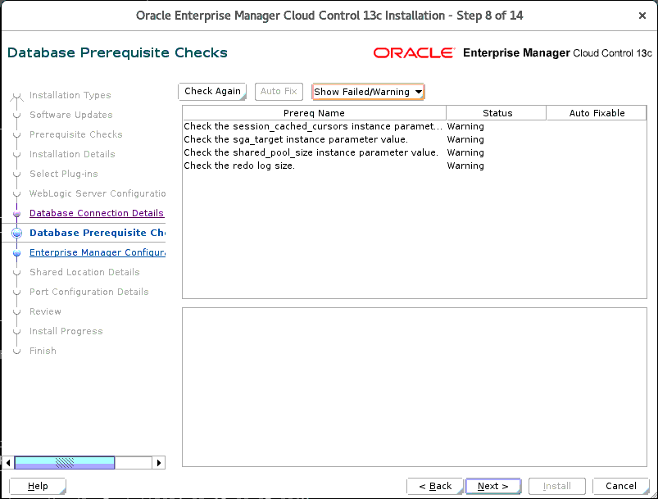

Paswd: oracle123

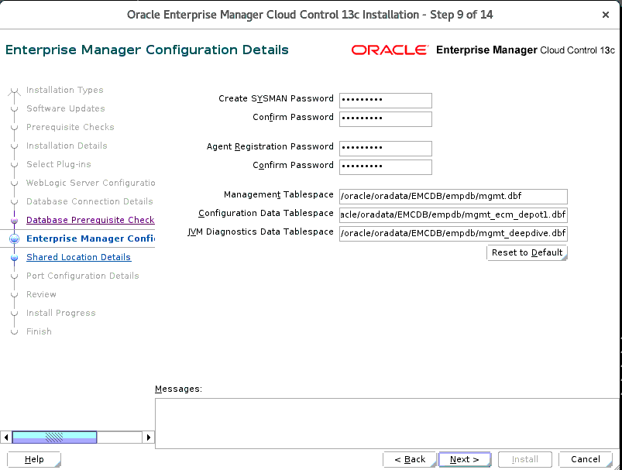

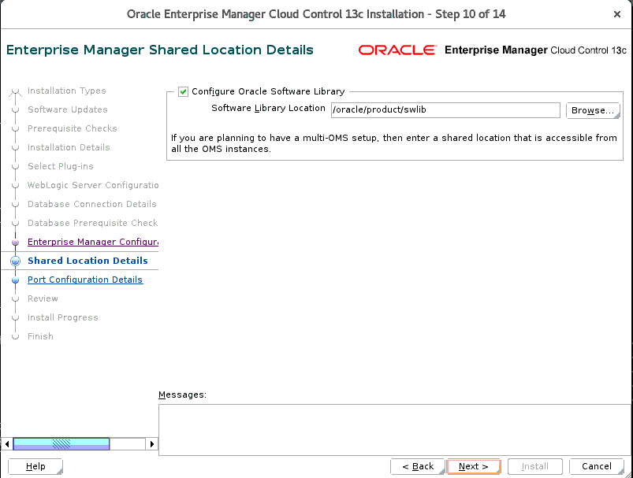

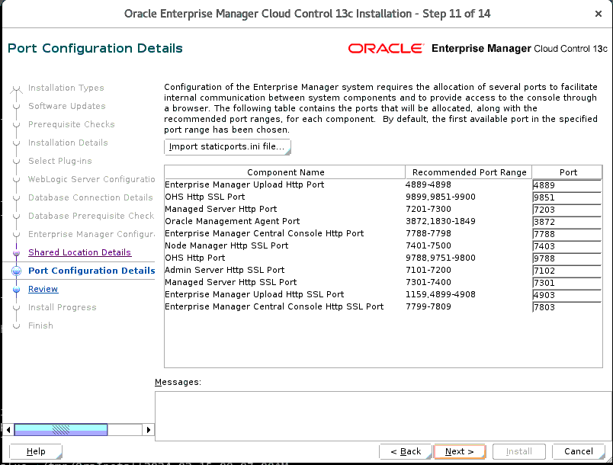

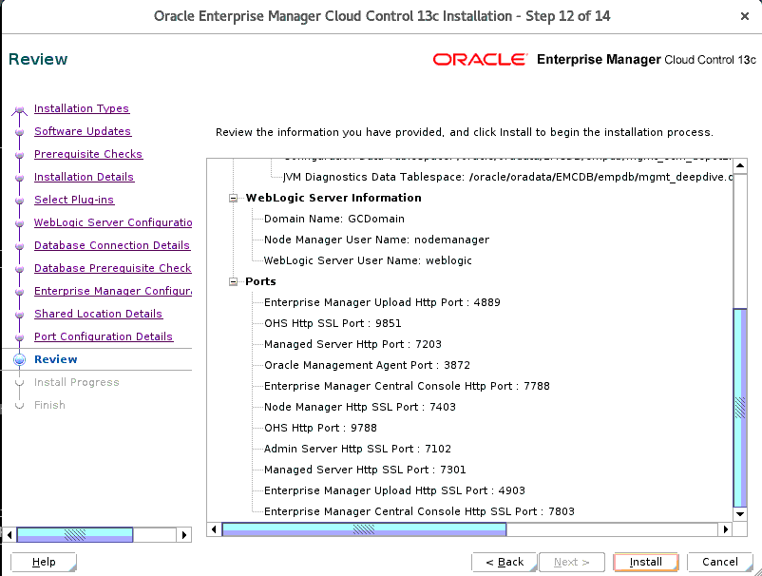

17:35

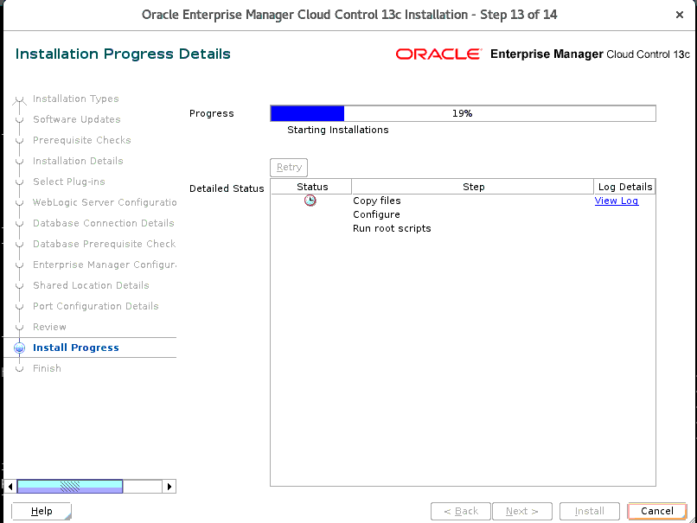

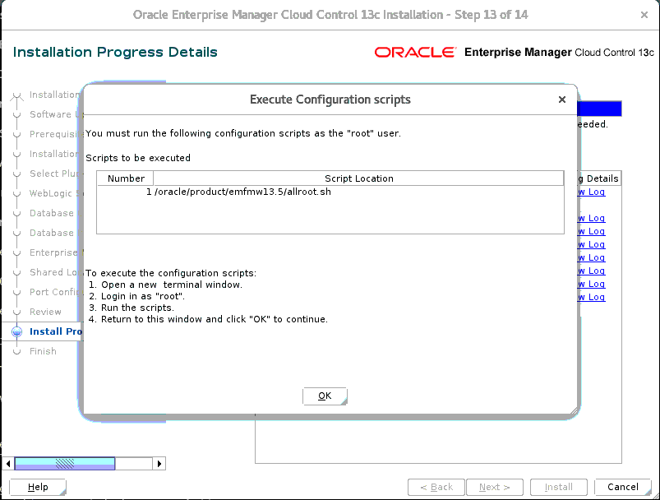

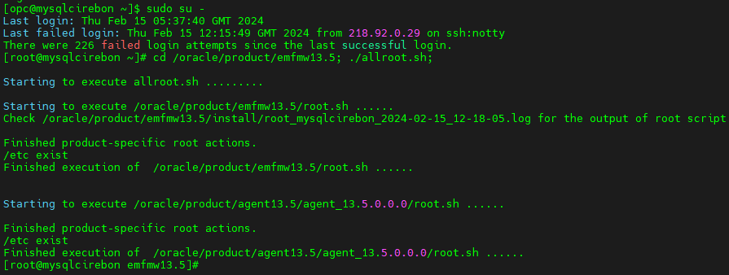

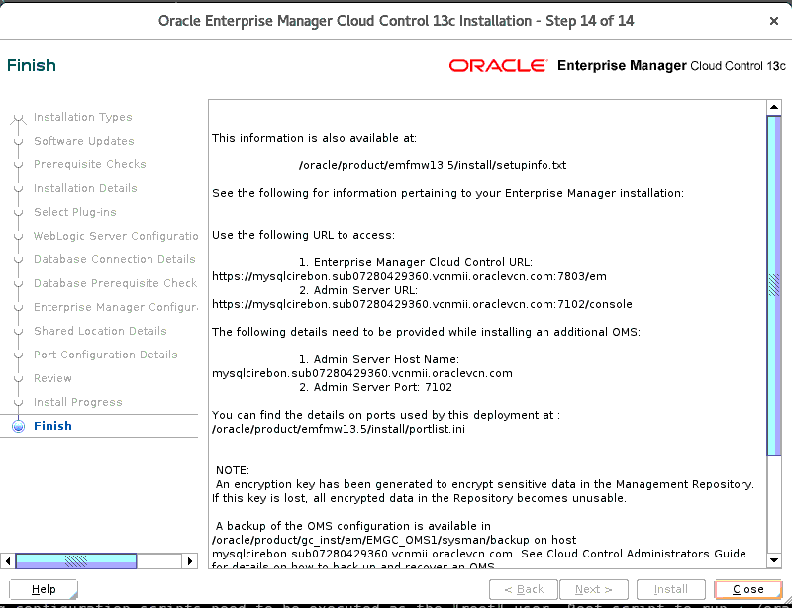

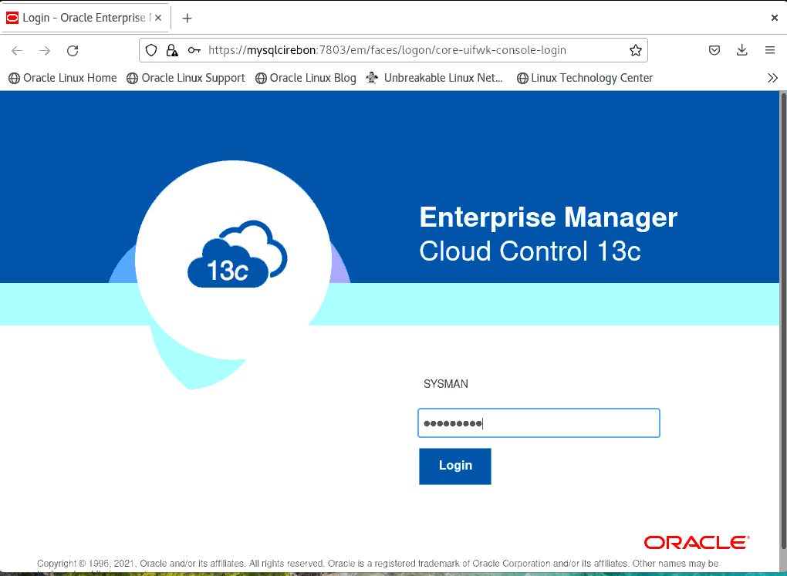

19.22

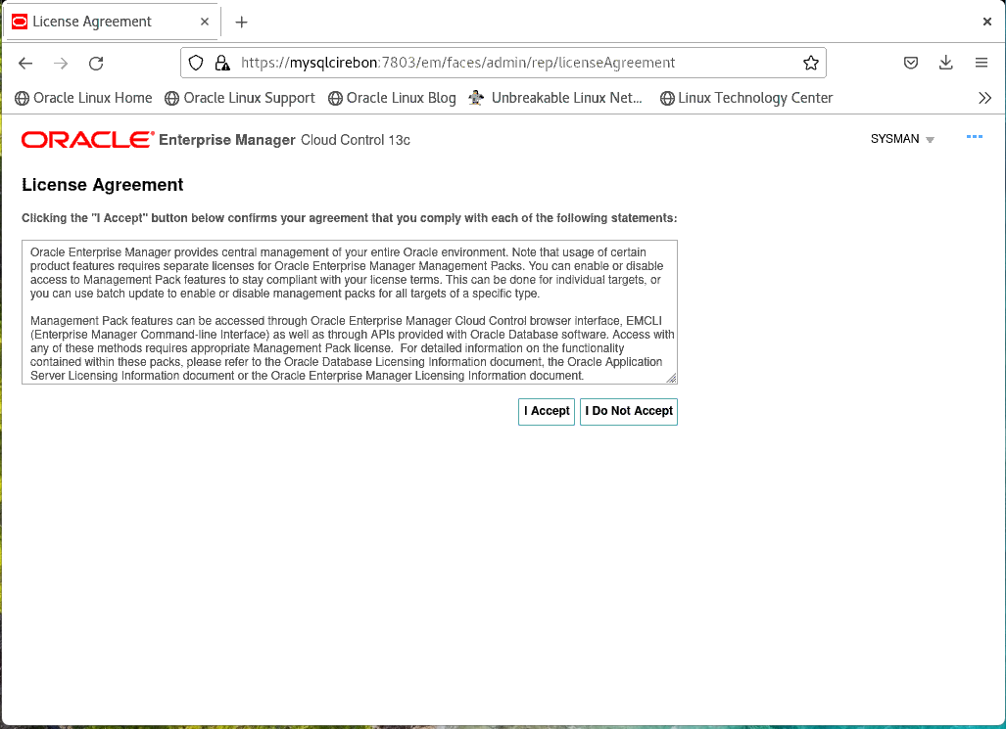

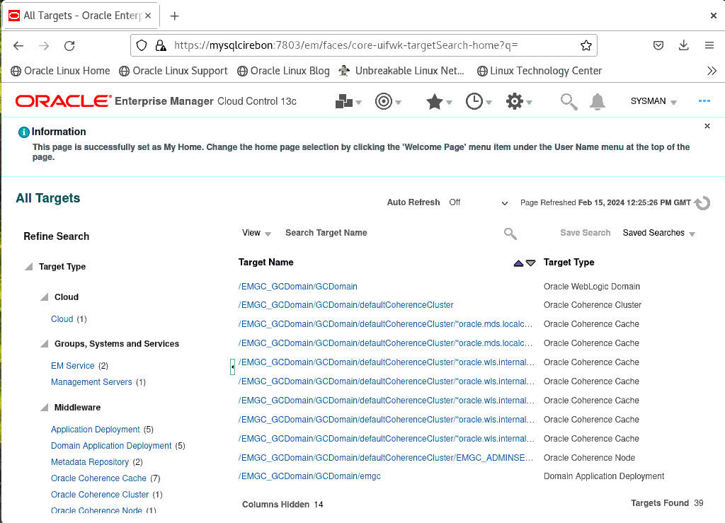

|  |
| --- |
| [oracle@mysqlcirebon ~]$ vi .bash_profile  [oracle@mysqlcirebon ~]$ cat .bash_profile  # .bash_profile  # Get the aliases and functions  if [ -f ~/.bashrc ]; then  . ~/.bashrc  fi  # User specific environment and startup programs  . /home/oracle/db_profile.env  export AGENT_HOME=/oracle/product/agent13.5/agent_inst  export OMS_HOME=/oracle/product/emfmw13.5  [oracle@mysqlcirebon ~]$ . .bash_profile  [oracle@mysqlcirebon ~]$ env|grep OMS_H  OMS_HOME=/oracle/product/emfmw13.5  [oracle@mysqlcirebon ~]$ env|grep AGENT_H  AGENT_HOME=/oracle/product/agent13.5/agent_inst  [oracle@mysqlcirebon ~]$ cd $AGENT_HOME/bin  [oracle@mysqlcirebon bin]$ ./emctl status agent  Oracle Enterprise Manager Cloud Control 13c Release 5  Copyright (c) 1996, 2021 Oracle Corporation. All rights reserved.  ---------------------------------------------------------------  Agent Version : 13.5.0.0.0  OMS Version : 13.5.0.0.0  Protocol Version : 12.1.0.1.0  Agent Home : /oracle/product/agent13.5/agent_inst  Agent Log Directory : /oracle/product/agent13.5/agent_inst/sysman/log  Agent Binaries : /oracle/product/agent13.5/agent_13.5.0.0.0  Core JAR Location : /oracle/product/agent13.5/agent_13.5.0.0.0/jlib  Agent Process ID : 233430  Parent Process ID : 233376  Agent URL : https://mysqlcirebon.sub07280429360.vcnmii.oraclevcn.com:3872/emd/main/  Local Agent URL in NAT : https://mysqlcirebon.sub07280429360.vcnmii.oraclevcn.com:3872/emd/main/  Repository URL : https://mysqlcirebon.sub07280429360.vcnmii.oraclevcn.com:4903/empbs/upload  Started at : 2024-02-15 12:16:37  Started by user : oracle  Operating System : Linux version 5.15.0-103.114.4.el8uek.x86_64 (amd64)  Number of Targets : 35  Last Reload : (none)  Last successful upload : 2024-02-15 12:31:41  Last attempted upload : 2024-02-15 12:31:41  Total Megabytes of XML files uploaded so far : 1.99  Number of XML files pending upload : 0  Size of XML files pending upload(MB) : 0  Available disk space on upload filesystem : 78.68%  Collection Status : Collections enabled  Heartbeat Status : Ok  Last attempted heartbeat to OMS : 2024-02-15 12:31:52  Last successful heartbeat to OMS : 2024-02-15 12:31:52  Next scheduled heartbeat to OMS : 2024-02-15 12:32:52  ---------------------------------------------------------------  Agent is Running and Ready  [oracle@mysqlcirebon bin]$ cd $OMS_HOME/bin  [oracle@mysqlcirebon bin]$ ./emctl status oms  Oracle Enterprise Manager Cloud Control 13c Release 5  Copyright (c) 1996, 2021 Oracle Corporation. All rights reserved.  WebTier is Up  Oracle Management Server is Up  JVMD Engine is Up  [oracle@mysqlcirebon admin]$ cd $OMS_HOME/bin  [oracle@mysqlcirebon bin]$ ./emctl stop oms -all  Oracle Enterprise Manager Cloud Control 13c Release 5  Copyright (c) 1996, 2021 Oracle Corporation. All rights reserved.  Stopping Oracle Management Server...  WebTier Successfully Stopped  Oracle Management Server Successfully Stopped  AdminServer Successfully Stopped  Oracle Management Server is Down  JVMD Engine is Down  [oracle@mysqlcirebon bin]$ cd $AGENT_HOME/BIN  -bash: cd: /oracle/product/agent13.5/agent_inst/BIN: No such file or directory  [oracle@mysqlcirebon bin]$ cd $AGENT_HOME/bin  [oracle@mysqlcirebon bin]$ ./emctl stop agent  Oracle Enterprise Manager Cloud Control 13c Release 5  Copyright (c) 1996, 2021 Oracle Corporation. All rights reserved.  Stopping agent ... stopped.  [oracle@mysqlcirebon bin]$ dbshut $ORACLE_HOME  Processing Database instance "EMCDB": log file /oracle/product/dbhome19c_1/rdbms/log/shutdown.log  [oracle@mysqlcirebon bin]$ |